No. 19 29 April 2003 – 07:50 UTC

BEPPOSAX REENTRY PREDICTIONS

Prepared by Luciano Anselmo and Carmen Pardini
Space Flight Dynamics Laboratory
Istituto di Scienza e Tecnologie dell’Informazione “Alessandro Faedo”
CNR - Area della Ricerca di Pisa, Via Moruzzi 1, 56124 Pisa, Italy
ASI Contract No. I/408/02/0
BeppoSAX Reentry Situation Room: bepposax@protezionecivile.it
tel. +39-06-6804-3255 ~ fax +39-06-6889-7689

GROUND IMPACT UNCERTAINTY WINDOW

Currently BeppoSAX is approaching the reentry into the densest layers of the earth atmosphere. The expected residual lifetime of the satellite was computed by propagating its last available state vector (epoch: 29 April 2003, 04:11 UTC) with a numerical trajectory predictor including all the relevant perturbations. Concerning the predicted solar flux at 10.7 cm and the geomagnetic planetary index A_{p}, the last 3-day forecast, issued by the NOAA Space Environment Center, was adopted.

Using for the final orbits of BeppoSAX the ballistic parameter estimated by fitting the altitude decay observed over 35 hours, the ground impact time window shown in Table 1 was obtained for the main debris. The confidence level associated with such a window is approximately 90%.

Table 1

Ground Impact Time Window for the BeppoSAX Main Debris

Impact Window | Impact Date | Impact Time
Opening | 29 April 2003 | 20:04 UTC
Nominal Impact | 29 April 2003 | 23:55 UTC
Closure | 30 April 2003 | 06:23 UTC

During the last three days three upper stage reentries have occurred: one over Brazil (a Russian Proton stage), in the morning of April 26, one over Central America (an American Atlas-Centaur stage), in the afternoon of April 27, and a third one over China (a Russian Soyuz stage), in the morning of April 28. A European Ariane third stage will reenter as well in the next 36 hours, in between 7.6 degrees North and South. It should be emphasized that none of the above-mentioned reentry events is related to BeppoSAX.

RISKY SUB-SATELLITE TRACKS

Due to the current uncertainty on the reentry time, significant areas of the equatorial belt in between 4.36 degrees North and South might still be affected by the impact of the surviving fragments of BeppoSAX. The sub-satellite ground tracks potentially at risk are shown in Figure 1.

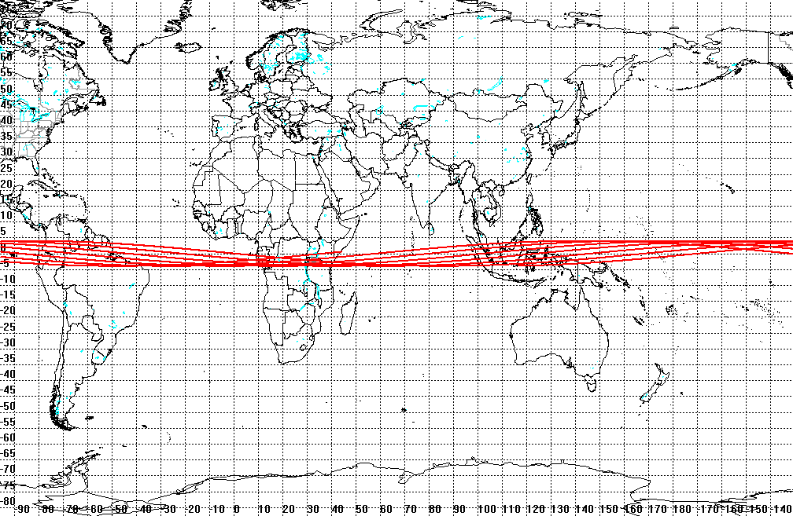

Fig. 1 – Sub-satellite tracks potentially at risk during the
impact time window given in Table 1

NEXT UPDATE

The next bulletin will be issued as soon as new significant results will be available.

•••••••••

