No. 21 29 April 2003 – 16:50 UTC

BEPPOSAX REENTRY PREDICTIONS

Prepared by Luciano Anselmo and Carmen Pardini
Space Flight Dynamics Laboratory
Istituto di Scienza e Tecnologie dell’Informazione “Alessandro Faedo”
CNR - Area della Ricerca di Pisa, Via Moruzzi 1, 56124 Pisa, Italy
ASI Contract No. I/408/02/0
BeppoSAX Reentry Situation Room: bepposax@protezionecivile.it
tel. +39-06-6804-3255 ~ fax +39-06-6889-7689

GROUND IMPACT UNCERTAINTY WINDOW

Currently BeppoSAX is approaching the reentry into the densest layers of the earth atmosphere. The expected residual lifetime of the satellite was computed by propagating its last available state vector (epoch: 29 April 2003, 07:08 UTC) with a numerical trajectory predictor including all the relevant perturbations. Concerning the predicted solar flux at 10.7 cm and the geomagnetic planetary index A_{p}, the last 3-day forecast, issued by the NOAA Space Environment Center, was adopted.

Using for the final orbits of BeppoSAX the ballistic parameter estimated by fitting the altitude decay observed during 34 hours, the ground impact time window shown in Table 1 was obtained for the main debris. The confidence level associated with such a window is approximately 90%.

Table 1

Ground Impact Time Window for the BeppoSAX Main Debris

Impact Window | Impact Date | Impact Time
Opening | 29 April 2003 | 20:35 UTC
Nominal Impact | 29 April 2003 | 23:51 UTC
Closure | 30 April 2003 | 05:17 UTC

During the last four days, three upper stage reentries have occurred: one over Brazil (a Russian Proton stage), in the morning of April 26, one over Central America (an American Atlas-Centaur stage), in the afternoon of April 27, and a third one over China (a Russian Soyuz stage), in the morning of April 28. A European Ariane third stage will reenter as well in the coming 36 hours, in between 7.6 degrees North and South. It should be emphasized that none of the above mentioned reentry events is related to BeppoSAX.

AREAS OF THE PLANET POTENTIALLY INVOLVED

Due to the current uncertainty on the reentry time, significant areas of the equatorial belt in between 4.36 degrees North and South might still be affected by the impact of the surviving fragments of BeppoSAX. The sub-satellite ground tracks potentially at risk are shown in Figure 1 and their coordinates are provided in Table 2.

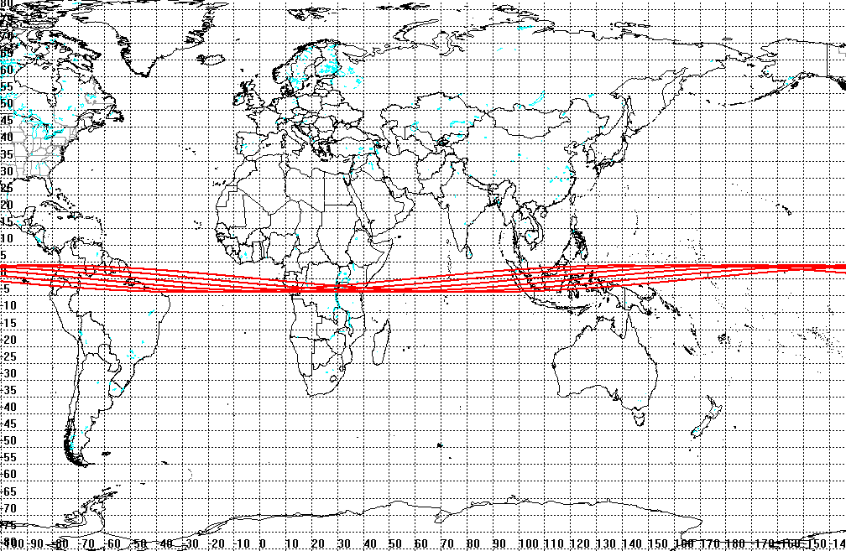

Fig. 1 – Sub-satellite tracks potentially at risk during the
impact time window given in Table 1

Table 2

Geographical Coordinates of the Ground Tracks Potentially at Risk

LAT (deg) | LON (deg E)
1.6029 | 213.6535
2.3416 | 225.1714
2.9729 | 236.7
3.4678 | 248.2397
3.8034 | 259.7891
3.9642 | 271.3448
3.9427 | 282.902
3.74 | 294.4558
3.3655 | 306.0018
2.8364 | 317.537
2.1773 | 329.0606
1.4184 | 340.574
0.5945 | 352.0805
-0.2566 | 3.5849
-1.0961 | 15.0926
-1.8855 | 26.6085
-2.5887 | 38.1366
-3.1731 | 49.6786
-3.6117 | 61.2342
-3.8842 | 72.8008
-3.9777 | 84.3737
-3.888 | 95.9477
-3.619 | 107.5174
-3.1833 | 119.0781
-2.601 | 130.627
-1.8992 | 142.1636
-1.1103 | 153.6894
-0.2705 | 165.2079
0.5815 | 176.7239
1.4069 | 188.2426
2.1677 | 199.7684
2.8289 | 211.3046
3.3602 | 222.8523
3.7368 | 234.4103
3.9415 | 245.9758
3.9645 | 257.5441
3.8051 | 269.1104
3.4704 | 280.67
2.9762 | 292.2194
2.3451 | 303.7573
1.6063 | 315.2844
0.7938 | 326.8037
-0.0552 | 338.3197
-0.9018 | 349.8378
-1.7071 | 1.363
-2.4341 | 12.8996
-3.0494 | 24.45
-3.5243 | 36.0142
-3.8368 | 47.5901
-3.9723 | 59.1737
-3.9243 | 70.7595
-3.6952 | 82.342
-3.2956 | 93.9163
-2.7439 | 105.4794
-2.0659 | 117.03
-1.2929 | 128.5694
-0.4605 | 140.1006
0.3931 | 151.6283
1.2284 | 163.1576
2.0073 | 174.6935
2.6939 | 186.2393
3.2564 | 197.7967
3.6689 | 209.3652
3.9122 | 220.9422
3.9749 | 232.5233
3.8542 | 244.1036
3.5556 | 255.6783
3.0931 | 267.2436
2.4881 | 278.7977
1.7685 | 290.3408
0.9676 | 301.8754
0.1221 | 313.4056
-0.7292 | 324.9369
-1.5471 | 336.4744
-2.2939 | 348.0226
-2.9351 | 359.5842
-3.441 | 11.16
-3.788 | 22.748
-3.9598 | 34.3446
-3.9484 | 45.9445
-3.7542 | 57.5422
-3.3863 | 69.1327
-2.8619 | 80.7121
-2.2055 | 92.2791
-1.4474 | 103.8344
-0.6226 | 115.381
0.2308 | 126.9231
1.0736 | 138.4662
1.8669 | 150.015
2.5741 | 161.5735
3.1626 | 173.1438
3.605 | 184.7258
3.8807 | 196.3171
3.9769 | 207.9138
3.8891 | 219.5109
3.6214 | 231.1035
3.1861 | 242.6876
2.6036 | 254.2608
1.9009 | 265.823
1.1105 | 277.3764
0.2689 | 288.9249
-0.5853 | 300.4735
-1.4128 | 312.0276
-2.1752 | 323.5919
-2.8372 | 335.1695
-3.3681 | 346.7612
-3.743 | 358.3658
-3.9443 | 9.9798
-3.9625 | 21.598
-3.7967 | 33.215
-3.4548 | 44.8255
-2.9526 | 56.4255
-2.3137 | 68.0131
-1.5678 | 79.5889
-0.7495 | 91.1554
0.1033 | 102.7169
0.9514 | 114.2788
1.7555 | 125.8461
2.4784 | 137.423
3.0867 | 149.0119
3.552 | 160.6131
3.8526 | 172.2245
3.9743 | 183.8425
3.9115 | 195.462
3.667 | 207.0782
3.2523 | 218.6867
2.6866 | 230.285
1.9965 | 241.8726
1.2137 | 253.4513
0.3747 | 265.0249
-0.4818 | 276.5984
-1.3161 | 288.1771
-2.0897 | 299.7658
-2.7665 | 311.3678
-3.315 | 322.9844
-3.7093 | 334.6144
-3.9309 | 346.2546
-3.9692 | 357.9
-3.8224 | 9.5451
-3.4974 | 21.1845
-3.0094 | 32.8142
-2.3813 | 44.432
-1.6425 | 56.0384
-0.8275 | 67.6356
0.0259 | 79.2281
0.8782 | 90.8211
1.6897 | 102.4199
2.4227 | 114.029
3.0431 | 125.651
3.5218 | 137.2864
3.8362 | 148.9336
3.9716 | 160.5887
3.9214 | 172.247
3.6878 | 183.9034
3.282 | 195.5536
2.7227 | 207.1949
2.0364 | 218.8267
1.2548 | 230.4507
0.4146 | 242.0707
-0.4453 | 253.6917
-1.2846 | 265.3192
-2.0642 | 276.9582
-2.3044 | 280.8411
-2.5325 | 284.7258
-2.7475 | 288.6123
-2.9481 | 292.5007
-3.1334 | 296.3909
-3.3023 | 300.2829
-3.454 | 304.1767
-3.5875 | 308.0721
-3.7023 | 311.9691
-3.7977 | 315.8676
-3.8732 | 319.7673
-3.9284 | 323.6682
-3.963 | 327.57
-3.9767 | 331.4726
-3.9696 | 335.3757
-3.9416 | 339.2792
-3.8929 | 343.1828
-3.8238 | 347.0863
-3.7345 | 350.9896
-3.6256 | 354.8925
-3.4976 | 358.7948
-3.3512 | 2.6964
-3.1872 | 6.5972
-3.0064 | 10.4971
-2.8099 | 14.396
-2.5985 | 18.2938
-2.3735 | 22.1904
-2.1361 | 26.0858
-1.8875 | 29.9798
-1.629 | 33.8721
-1.3621 | 37.7624
-1.0881 | 41.6501
-0.8087 | 45.5339
-0.5255 | 49.4119
-0.2403 | 53.2797
0.0447 | 57.1277
0.3262 | 60.9318
0.5968 | 64.6104
0.8324 | 67.8458
0.9658 | 69.6982
0.992 | 70.064

Taking into account the predicted dispersion of the fragments and the trajectory inaccuracies, the half width of the risky ground swath Σ associated with the above mentioned ground tracks is a function of the sub-satellite latitude λ, North or South, as given by the following equation:

$Σ(\text{km})=\text{42}+\text{258}\text{.}\text{95}\text{sin}\left(3\text{.}\text{978}°−\left|λ\right|\right)$. (1)

Figure 2 shows how the risky ground swath half width Σ varies as a function of the sub-satellite latitude λ, North or South, both in kilometers and nautical miles. As an example, the half width of the risky ground swath associated with a sub-satellite point on the equator (λ = 0°) is 60 km, that is all the locations at less than 60 km from the sub-satellite track are potentially at risk. The swath half width decreases at higher latitudes, North or South, reaching the minimum value of 42 km at λ = ± 3.978°.

Fig. 2 – Half width of the risky ground swath as a function
of the sub-satellite track latitude

The countries or territories that might still be potentially hit by the BeppoSAX falling fragments are:

- Africa: Burundi, Congo, Democratic Republic of Congo, the Pagalu Island of Equatorial Guinea, Gabon, Kenya, Rwanda, São Tomé and Príncipe, Seychelles, Somalia, Tanzania;

- Asia: Indonesia, Malaysia, Maldives, Singapore;

- Oceania: Baker Island (USA), Federated States of Micronesia, Howland Island (USA), Kiribati, Marshall Islands, Nauru, Palau, Papua New Guinea;

- South America: Brazil, Colombia, Ecuador, French Guiana, Guyana, Peru, Suriname, Venezuela.

The following countries or territories of the equatorial belt in between 4.36 degrees North and South are instead not included anymore – with a confidence level of 90% or higher – in the areas at risk for the BeppoSAX falling fragments: Cameroon, Central African Republic, the continental Equatorial Guinea, Ethiopia, Sudan, Uganda, Cap Palmas, at the border between Liberia and Côte d’Ivoire, the Niger river delta, in Nigeria, Brunei, Jarvis Island (USA).

LONGITUDINAL RISK TIME WINDOWS

A nominal impact time for the BeppoSAX main debris may be associated with any sub-satellite point of the risky ground tracks shown in Figure 1. By taking into account an impact uncertainty of ± 10 minutes and the time needed for the small centimeter sized particulate produced by the event to rain down through the affected air space (+ 20 minutes), a risk time window of 40 minutes can be associated with any specific location along the final sub-satellite tracks, as follow:

Risk Time Window = Predicted Main Debris Impact Time (UTC) $\left\{\frac{+\text{30}\text{min}}{−\text{10}\text{min}}\right.$. (2)

Table 3 lists the impact risk time windows, as a function of longitude, for the sub-satellite ground tracks potentially at risk, shown in Figures 1 and 3-6.

Table 3

Impact Risk Time Windows (UTC) Along the Risky Ground Tracks

Longitude Band | Track No. 1 | Track No. 2 | Track No. 3 | Track No. 4 | Track No. 5 | Track No. 6
180° – 120° W | 29 APR 2017-2112 | 29 APR 2150-2245 | 29 APR 2323  30 APR 0018 | 30 APR 0056-0152 | 30 APR 0228-0323 | 30 APR 0403-0458
120° – 60° W | 29 APR 2032-2127 | 29 APR 2205-2301 | 29 APR 2338  30 APR 0033 | 30 APR 0112-0218 | 30 APR 0243-0340 | 30 APR 0418-0514
60° W – 0° | 29 APR 2047-2143 | 29 APR 2221-2316 | 29 APR 2353  30 APR 0048 | 30 APR 0128-0222 | 30 APR 0300-0356 | 30 APR 0434-0529
0° – 60° E | 29 APR 2103-2158 | 29 APR 2236-2331 | 30 APR 0008-0104 | 30 APR 0142-0238 | 30 APR 0316-0412 | 30 APR 0449-0545
60° – 120° E | 29 APR 2118-2215 | 29 APR 2251-2347 | 30 APR 0024-0120 | 30 APR 0158-0253 | 30 APR 0332-0427 | 30 APR 0505-0600
120° – 180° E | 29 APR 2135-2230 | 29 APR 2307  30 APR 0003 | 30 APR 0040-0136 | 30 APR 0213-0308 | 30 APR 0347-0443 | 30 APR 0520-0615

CONTINENTAL RISK MAPS

The sub-satellite ground tracks at risk are presented in further detail, for specific continental areas, in the following maps (Figures 3-6).

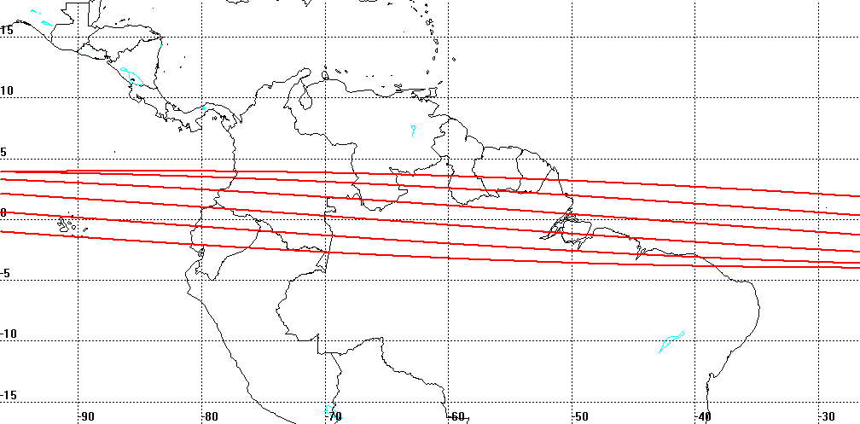

Fig. 3 – Sub-satellite tracks potentially at risk over South America

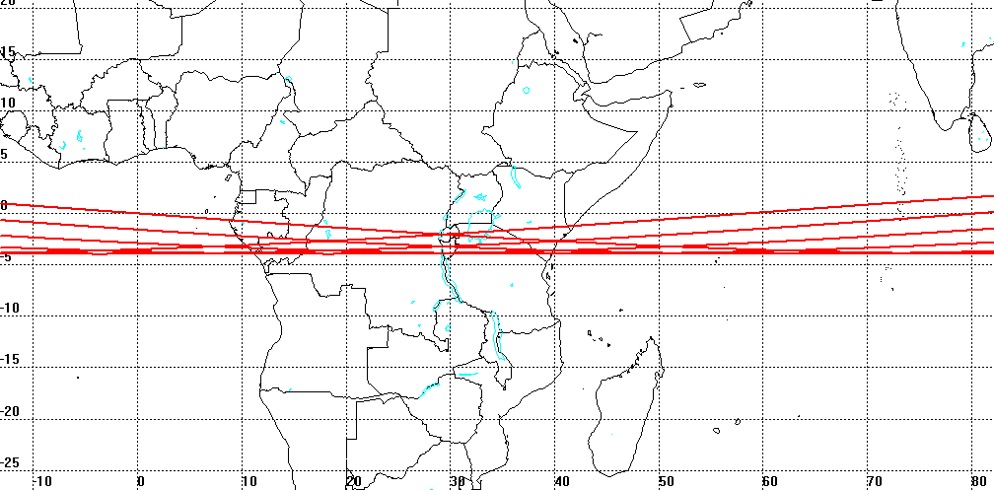

Fig. 4 – Sub-satellite tracks potentially at risk over Africa and Maldives

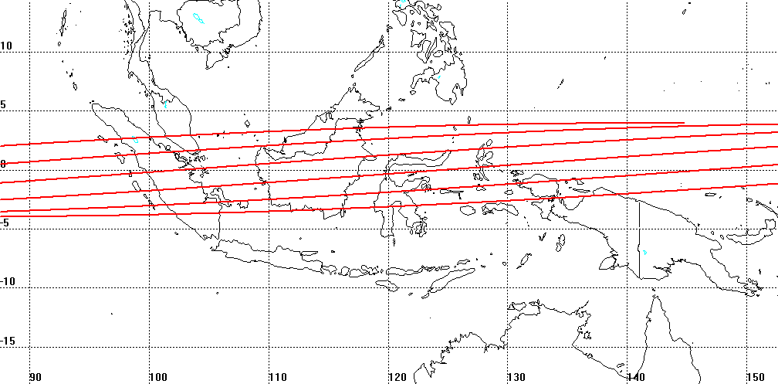

Fig. 5 – Sub-satellite tracks potentially at risk over Southeast Asia

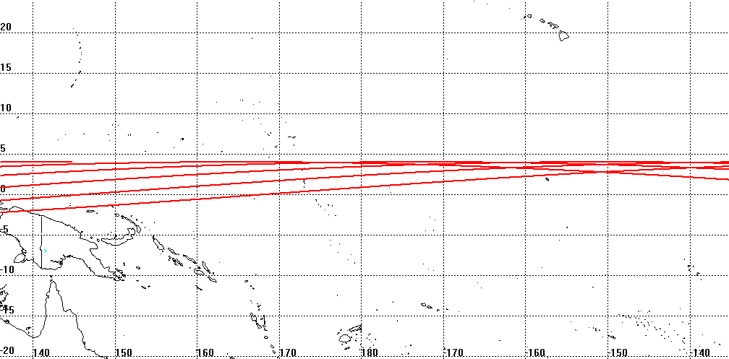

Fig. 6 – Sub-satellite tracks potentially at risk over Oceania

NEXT UPDATE

The next bulletin will be issued as soon as new significant results are available.

•••••••••

