No. 23 29 April 2003 – 21:40 UTC

BEPPOSAX REENTRY PREDICTIONS

Prepared by Luciano Anselmo and Carmen Pardini
Space Flight Dynamics Laboratory
Istituto di Scienza e Tecnologie dell’Informazione “Alessandro Faedo”
CNR - Area della Ricerca di Pisa, Via Moruzzi 1, 56124 Pisa, Italy
ASI Contract No. I/408/02/0
BeppoSAX Reentry Situation Room: bepposax@protezionecivile.it
tel. +39-06-6804-3255 ~ fax +39-06-6889-7689

GROUND IMPACT UNCERTAINTY WINDOW

Currently BeppoSAX is approaching the reentry into the densest layers of the earth atmosphere. The expected residual lifetime of the satellite was computed by propagating its last available state vector (epoch: 29 April 2003, 18:52 UTC) with a numerical trajectory predictor including all the relevant perturbations. Concerning the predicted solar flux at 10.7 cm and the geomagnetic planetary index A_{p}, the last 3-day forecast, issued by the NOAA Space Environment Center, was adopted.

Using for the final orbits of BeppoSAX the ballistic parameter estimated by fitting the altitude decay observed during 19 hours, the ground impact time window shown in Table 1 was obtained for the main debris. The confidence level associated with such a window is approximately 90%.

Table 1

Ground Impact Time Window for the BeppoSAX Main Debris

Impact Window | Impact Date | Impact Time
Opening | 29 April 2003 | 22:48 UTC
Nominal Impact | 29 April 2003 | 23:36 UTC
Closure | 30 April 2003 | 00:57 UTC

AREAS OF THE PLANET POTENTIALLY INVOLVED

Due to the current uncertainty on the reentry time, significant areas of the equatorial belt in between 4.36 degrees North and South might still be affected by the impact of the surviving fragments of BeppoSAX. The sub-satellite ground tracks potentially at risk are shown in Figure 1.
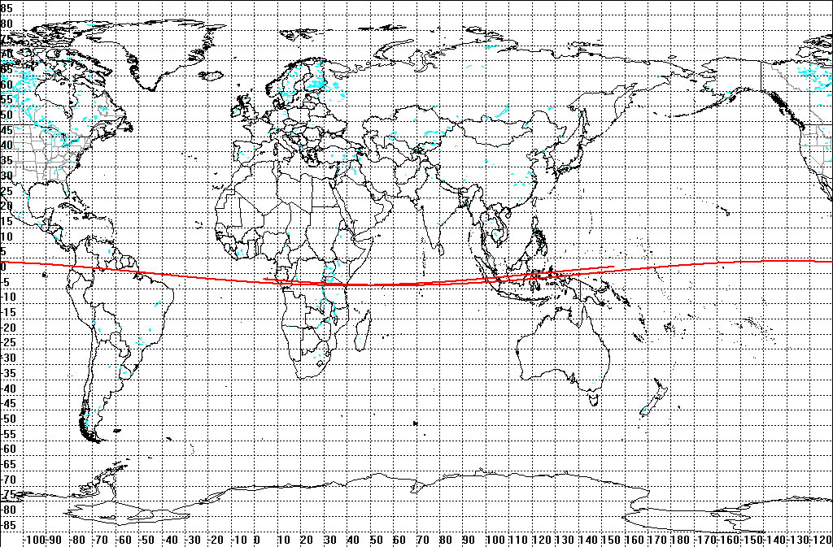

Fig. 1 – Sub-satellite tracks potentially at risk during the
impact time window given in Table 1

The countries or territories that might still be potentially hit by the BeppoSAX falling fragments are:

- Africa: Burundi, Congo, Democratic Republic of Congo, Gabon, Kenya, Rwanda, Seychelles, Tanzania;

- Asia: Indonesia, Maldives;

- Oceania: Federated States of Micronesia, Kiribati, Palau;

- South America: Brazil, Colombia, Guyana, Venezuela.

The following countries or territories of the equatorial belt in between 4.36 degrees North and South are instead not included anymore – with a confidence level of 90% or higher – in the areas at risk for the BeppoSAX falling fragments: Cameroon, Central African Republic, Equatorial Guinea, Ethiopia, Sudan, Uganda, Cap Palmas, at the border between Liberia and Côte d’Ivoire, the Niger river delta, in Nigeria, Brunei, São Tomé and Príncipe, Nauru, French Guiana, Suriname, Somalia, Malaysia, Singapore, Marshall Islands, Papua New Guinea, Ecuador, Peru, Baker Island (USA), Howland Island (USA), Jarvis Island (USA).

LONGITUDINAL RISK TIME WINDOWS

Table 2 lists the impact risk time windows, as a function of longitude, for the sub-satellite ground tracks potentially at risk, shown in Figures 1 and 2-5.

Table 2

Impact Risk Time Windows (UTC) Along the Risky Ground Tracks

Longitude Band | Track No. 1 | Track No. 2
180° – 120° W |  | 29 APR 2323  30 APR 0018
120° – 60° W |  | 29 APR 2338  30 APR 0033
60° W – 0° |  | 29 APR 2353  30 APR 0048
0° – 60° E | 29 APR 2236-2331 | 30 APR 0008-0104
60° – 120° E | 29 APR 2251-2347 | 30 APR 0024-0120
120° – 180° E | 29 APR 2307  30 APR 0003 | 30 APR 0040-0136

CONTINENTAL RISK MAPS

The sub-satellite ground tracks at risk are presented in further detail, for specific continental areas, in the following maps (Figures 2-5), where a ground swath half width of 60 km was assumed as an example.

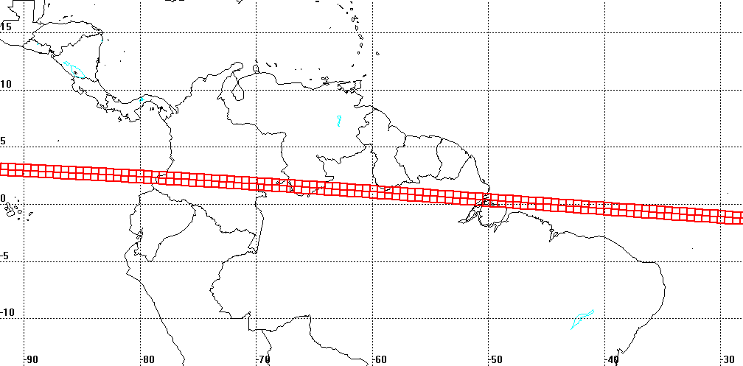

Fig. 2 – Sub-satellite track potentially at risk over South America
No. 2 of Table 2

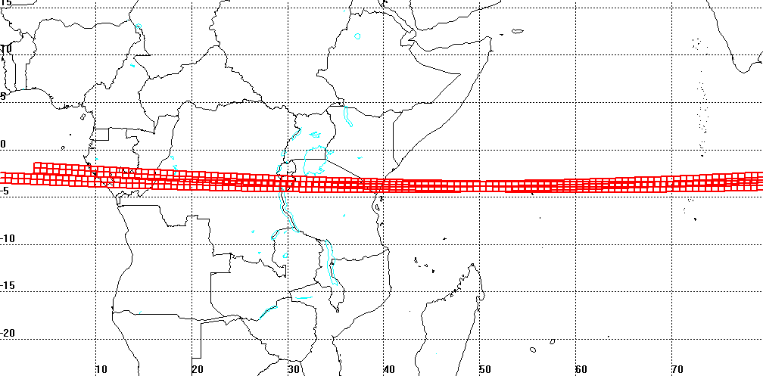

Fig. 3 – Sub-satellite tracks potentially at risk over Africa and Maldives
Northern track: No. 1 of Table 2
Southern track: No. 2 of Table 2

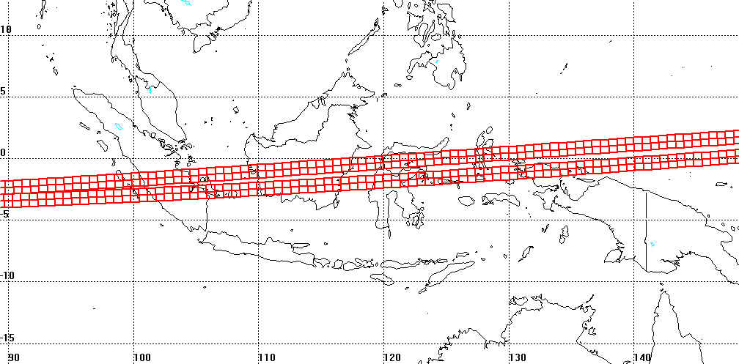

Fig. 4 – Sub-satellite tracks potentially at risk over Southeast Asia
Northern track: No. 2 of Table 2
Southern track: No. 1 of Table 2

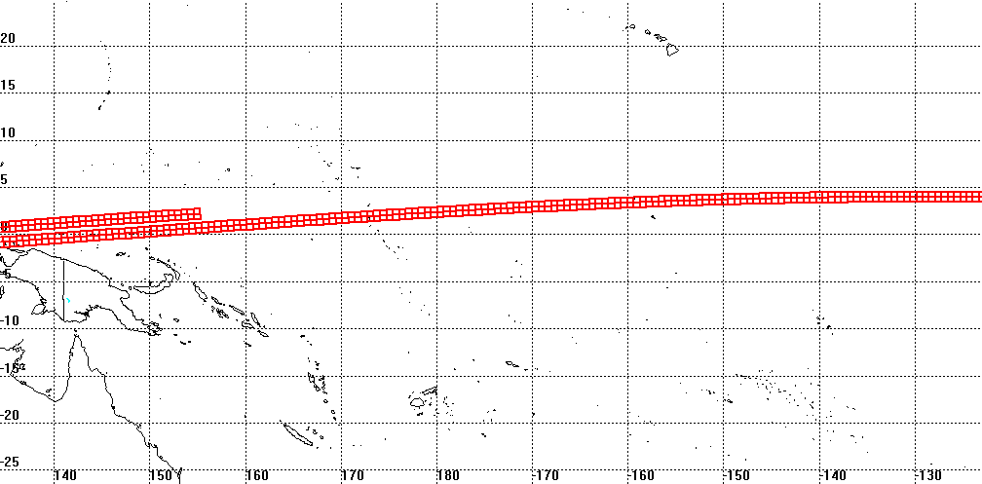

Fig. 5 – Sub-satellite tracks potentially at risk over Oceania
Northern track: No. 2 of Table 2
Southern track: No. 1 of Table 2

NEXT UPDATE

The next bulletin will be issued as soon as new significant results are available.

•••••••••

