No. 24 30 April 2003 – 00:45 UTC

BEPPOSAX REENTRY REPORT

Prepared by Luciano Anselmo and Carmen Pardini
Space Flight Dynamics Laboratory
Istituto di Scienza e Tecnologie dell’Informazione “Alessandro Faedo”
CNR - Area della Ricerca di Pisa, Via Moruzzi 1, 56124 Pisa, Italy
ASI Contract No. I/408/02/0
BeppoSAX Reentry Situation Room: bepposax@protezionecivile.it
tel. +39-06-6804-3255 ~ fax +39-06-6889-7689

BEPPOSAX REENTRY

Based on the American Space Surveillance Network assessment, the estimated ground impact time for the BeppoSAX main debris was 29 April 2003, 22:06 UTC, with an uncertainty window of plus or minus 7 minutes. Figure 1 shows the sub-satellite ground track corresponding to the above mentioned decay window. A ground swath half width of 60 km was assumed.

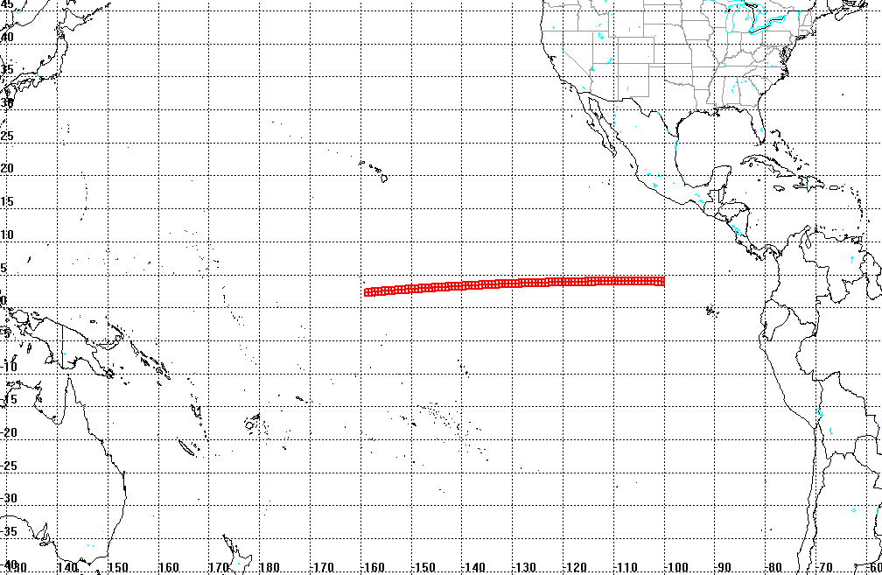

Fig. 1 – Sub-satellite track corresponding to the BeppoSAX decay window

No visual report concerning the satellite reentry time and area is at present available.

