No. 25 30 April 2003 – 09:30 UTC

BEPPOSAX REENTRY REPORT

Prepared by Luciano Anselmo and Carmen Pardini
Space Flight Dynamics Laboratory
Istituto di Scienza e Tecnologie dell’Informazione “Alessandro Faedo”
CNR - Area della Ricerca di Pisa, Via Moruzzi 1, 56124 Pisa, Italy
ASI Contract No. I/408/02/0
BeppoSAX Reentry Situation Room: bepposax@protezionecivile.it
tel. +39-06-6804-3255 ~ fax +39-06-6889-7689

BEPPOSAX REENTRY

Using for the final orbits of BeppoSAX the ballistic parameter estimated by considering the altitude decay observed during 7.3 hours (last couple of two line orbital elements available), the ground impact time window shown in Table 1 was estimated for the main debris. Figures 1 and 2 show the sub-satellite ground track corresponding to the above mentioned decay window. A ground swath half width of 60 km was assumed.

Table 1

Ground Impact Time Window for the BeppoSAX Main Debris

Impact Window | Impact Date | Impact Time
Opening | 29 April 2003 | 21:45 UTC
Nominal Impact | 29 April 2003 | 22:43 UTC
Closure | 29 April 2003 | 23:43 UTC

The nominal reentry location, based on the American Space Surveillance Network assessment, is shown in the figures. It is affected by an uncertainty of plus or minus 3000 km along the trajectory. No visual report concerning the satellite reentry time and area is at present available.

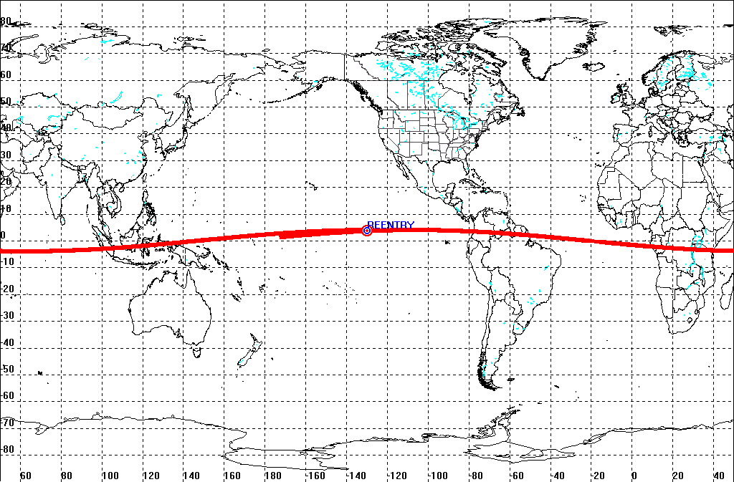

Fig. 1 – Sub-satellite track corresponding to the BeppoSAX decay window

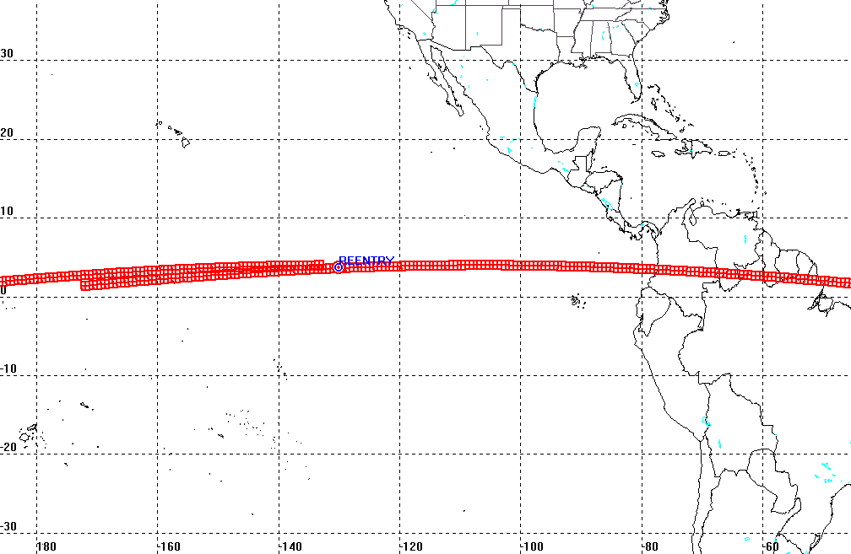

Fig. 2 – BeppoSAX reentry area

