First Report on the Reentry of the ASI Satellite BeppoSAX

ASI - Ground Segment
The BeppoSAX Mission Director
L. Salotti

SUMMARY

INTRODUCTION 3
ACTUAL STATUS OF BEPPO-SAX 5
GENERAL FORECAST ON THE REENTRY 5
STATES POTENTIALLY AFFECTED BY THE BEPPOSAX REENTRY AND INFORMATION DISPATCHING 7

INTRODUCTION

This document is the first report dealing with the technical aspects of the reentry on the Earth of the Italian Satellite for X-ray Astronomy ‘BeppoSAX’ as a consequence of the orbital decaying. The BeppoSAX satellite is owned by the Italian Space Agency – Viale Liegi 26 00198 Rome Italy.

The goal of this first report is to define the general scenario of the reentry and to provide useful information to the Governments of the States whose territories are potentially affected by this event as well as to the International Authorities regulating the air and sea navigation and the United Nations dedicated committees.

ASI and the Italian Government are devoting particolar attention to the reentry of BeppoSAX and have activated a program for dispatching information on this event by means of the issue of periodical reports which will be transmitted through the diplomatic channels and made available to the public via the Internet at the following address since January 1st 2003:

http://www.asdc.asi.it/bepposax/reentry/

The BeppoSAX mission was a program of the Italian Space Agency for the launch and the operation of an orbiting observatory for the study of the X-ray radiation of celestial origin. ASI was joined in this program by the Dutch Space Agency (NIVR) who provided a financial support and part of the flight hardware. The embarked scientific instruments were provided by Italian Space Industries, by the European Space Agency (ESA) and by the Dutch Scientific Institute SRON.

The name of the satellite was originally SAX (‘Satellite per Astronomia X’) but was changed, following the successful launch in orbit, into BeppoSAX after the well known Italian Astrophysicist Giuseppe ‘Beppo’ Occhialini.

The spacecraft was designed and assembled by Alenia Spazio S.p.A of Turin and controlled in orbit by Telespazio S.p.A of Rome. The Operation Control Centre was located in Rome at the Telespazio premises while the Ground Station was the ASI Malindi Ground Station in Kenya.

The BeppoSAX mass is about 1400 kg and the spatial dimensions are:

2,4 m x 3,6 x 18 m

where the largest extension (18 m) is accounted by the solar arrays.

BeppoSAX was launched into space from the NASA Kennedy Space Centre in Florida (USA) on April 30th 1996 at 4.31 GMT by an Atlas/Centaur vehicle. The injecting orbit was circular at an altitude of 600 km and essentially equatorial (3.95° inclination).

In the following page BeppoSAX is shown with the accomodation of the scientific instruments (Figure 1).

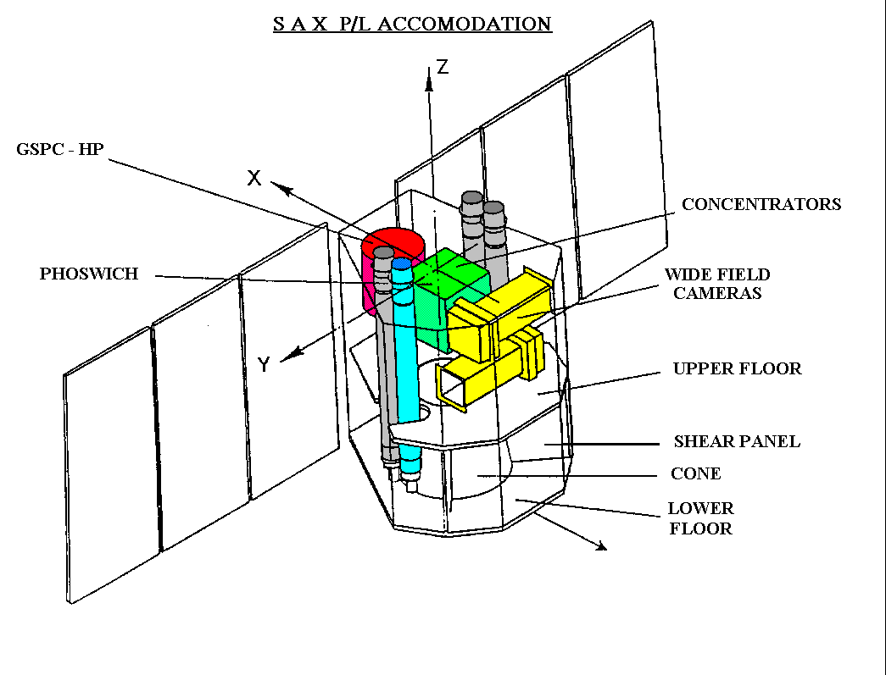

Figure 1 – BeppoSAX with the accomodation of the scientific instruments highlighted

ACTUAL STATUS OF BEPPO-SAX

During the course of a six years lifetime BeppoSAX has successfully accomplished a set of observation programmes providing a general and deep coverage of the X-ray radiation of celestial origin. In addition, the BeppoSAX results were crucial for the recent breakthrough of the Gamma Ray Burst Astrophysics which eventually led to significant international awards such as the 1998 ‘Bruno Rossi’ prize assigned by the American Astronomical Society to the BeppoSAX team.

The operative life of BeppoSAX eventually ended in the spring of 2002 following the ASI decision to deactivate the satellite. Such a long and successful life was essentially due to the excellent performance of the embarked instrumentation and to the bus subsystems.

The decision to end the BeppoSAX operative life was due to two converging factors:

- a progressive and irreversible ageing of the on board batteries (NiCmd);
- a progressive decaying of the orbiting altitude to the level of 450 km where the attitude control subsystem was no more able to counter-balance the disturbance torques;

During the first quarter of 2002 these factors significantly reduced the observing efficiency and eventually lowered the cost-effectiveness of the mission.

BeppoSAX has been switched off from the Control Centre in Rome on April 30th 2002 using a procedure which successfully ended at 13.18 GMT.

The switch off procedure was designed in order to provide full compliance with the international agreements for mitigation of the space debris production and for satellite reentries. The main guideline was the inhibition of all residual energy sources present on board in order to prevent any explosion of the satellite before the reentry phase.

The switch off procedure applied to BeppoSAX is irrevocable and the spacecraft cannot be commanded from ground anymore. Accordingly, since April 30th 2002 BeppoSAX is a space debris without attitude control and subject only to the law of the orbital decay.

Inside the BeppoSAX rear tank are still stored 26 kg of Hydrazine (N2H4) and 0,5 kg of the GN2 pressurizant.

BeppoSAX does not store any fissionable element.

GENERAL FORECAST ON THE REENTRY

At the time of writing (December 2nd 2002) the orbiting altitude of BeppoSAX is in the range 403-409 km and, considering the actual conditions of the atmospheric thermo-density at that altitude, the reentry on the dense layers of the atmosphere (100 km) is foreseen for the spring of 2003.

This prediction is linked to the actual thermo-density profile of the atmosphere which is, in turn, dependent upon the solar activity in the ultraviolet domain. The solar activity is presently following the decreasing phase of the 11 years duty cycle of the sun. However, an unexpected upraise of the solar activity may induce a consequent increase of the atmospheric density with an acceleration of the orbital decay of BeppoSAX. This event, while possible, has a low probability and my be quantified, as a worst case, in an anticipation of the reentry date of one or two months. On the other hand, an harder than expected decrease of the solar activity may shift the reentry date late in 2003.

ASI has carefully studied the destructive reentry of BeppoSAX on the Earth by means of a dedicated contract to a top ranking European firm in this field. The results of the study are the following:

- the destructive reentry of BeppoSAX will start at an altitude of 100 km and will conclude in approximately 40 minutes;
- BeppoSAX will be subject to a progressive fragmentation with some fragments completely vaporized by the atmospheric drag and some other fragments reaching the ground level;
- approximately 40 fragments will reach the ground level for a total mass of 650 kg; the heaviest fragment may have a mass of the order of 100 kg;
- the fragment shower will impact the ground level on the Earth equatorial belt; the affected area will have an extension of 10000 kmq probably with the form of a strip of 315 km x 32 km;
- the fragment velocity of impact on the ground will be in the range 60-460 km/h;
- the summed cross section of the fragments reaching the ground will be about 30 m2; this figure is higher than the ‘attention’ cross section threshold applied by NASA (8 m2);

These results should be retained as ‘order of magnitude’ and not precise determinations given the stochastic nature of the event and the approximations inherent in the BeppoSAX model that was used.

In the next figure the mass distribution of the fragment shower reaching the ground is displayed (Figure 2).

Figure 2 – Mass distribution of the fragment shower

STATES POTENTIALLY AFFECTED BY THE BEPPOSAX REENTRY AND INFORMATION DISPATCHING

Figure 3 displays the equatorial belt potentially affected by the BeppoSAX reentry and Table 1 lists all the States whose territory lie inside the range –4°/+4° latitude. For the potentially affected countries a 1990 population distribution is listed in cells 1° longitude x 1° latitude wide.

ASI, on behalf of the Government of the Republic of Italy, has actively spurred the process of mitigation of the space debris generation and applies the guidelines listed in the following documents

- Technical Report on Space Debris, adopted by the Scientific and Technical Subcommittee of the United Nations Committee on the Peaceful Uses of Outer Space (UNCOPUOS), United Nations, New York, 1999;
- European Space Debris Safety and Mitigation Standard, European Debris Mitigation Standard Working Group, Issue 1, Revision 0, September 27, 2000;
- IADC Space Debris Mitigation Guidelines, Inter-Agency Space Debris Coordination Committee (IADC), Working Group 4, Draft of March 23, 2001.

Within this context ASI is willing to provide the more complete and transparent information about the reentry of BeppoSAX to all States whose territories may be potentially interested by the impact of the BeppoSAX fragments as well as to the International Authorities regulating the air and sea navigation and the dedicated committees of the United Nations. This information will be contained in periodical reports listing the following items:

    - best estimate of the BeppoSAX reentry date with a progressively precise indication of the time window(s) of the foreseen impact of the fragment shower on the ground;
    - best estimate of the geographical area of impact of the fragment shower;
    - evaluation of the casualty risk inherent to the BeppoSAX reentry with indication of the inclusion/exclusion of the major population concentrations;

All communications about this event will be available via internet at the following address since January 1st 2003:
I
http://www.asdc.asi.it/bepposax/reentry/

Rome, December 2nd 2002
Luca Salotti
BeppoSAX Mission Director
ASI – Ground Segment

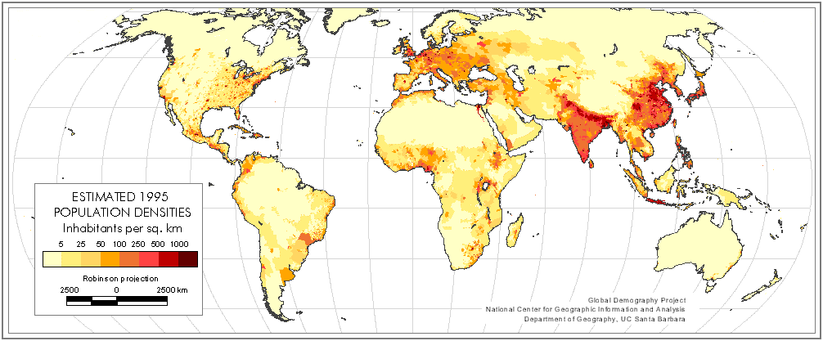

Figure 3 – Positioning of the equatorial belt potentially affected by the BeppoSAX reentry with shadowing reflecting the population density

Table 1 - 1990 Population distribution divided in cells 1° Longitude x 1° Latitude wide

