No. 2 16 January 2003

BEPPOSAX REENTRY PREDICTIONS

Istituto di Scienza e Tecnologie dell’Informazione “Alessandro Faedo”
CNR - Area della Ricerca di Pisa, Via Moruzzi 1, 56124 Pisa, Italy
ASI Contract No. I/408/02/0
Technical Manager: Carmen Pardini [Carmen.Pardini@cnuce.cnr.it]
Contact Point: Luciano Anselmo [Luciano.Anselmo@cnuce.cnr.it]
tel. +39-050-315-2952 ~ fax +39-050-313-8091

SATELLITE ORBITAL STATUS

Currently, the BeppoSAX satellite completes a revolution around the earth every 92 minutes at an altitude in between 381 km (perigee) and 386 km (apogee). The orbit is inclined by 3.95 degrees with respect to the equator, which means the satellite may fly over any location included in the latitude band between 3.98 degrees North and South. However, the motion is significantly perturbed by the residual atmosphere present at that altitude. The main effect of the resulting drag force is a progressively increasing altitude loss, which will culminate in the satellite reentry on the earth.

Because the orbit is near circular, the average altitude loss per revolution (Δh_{rev}) may be approximated using the following equation:

Δh_{rev} = – 2π(C_{D}A/m)ρa²

In it ρ is the average atmospheric density along the orbit, a is the semi-major axis (i.e. the average distance from the center of the earth), while C_{D}, m and A are, respectively, the satellite drag coefficient, mass and average cross-sectional area.

BALLISTIC PARAMETER ESTIMATION

The ballistic parameter B, defined according to the relationship

B = C_{D}A/m

was estimated by fitting, in a least squares sense, the satellite semi-major axis decay observed from 15 December 2002 to 15 January 2003 (Figure 1). All the relevant orbit perturbations were included and the Jacchia-Roberts 1971 model was adopted to describe the varying atmospheric density. The orbital data, as USSPACECOM two-line elements, were provided by the NASA/GSFC Orbital Information Group. The nominal ballistic parameter obtained was B_{N} = 0.02272 m²/kg.
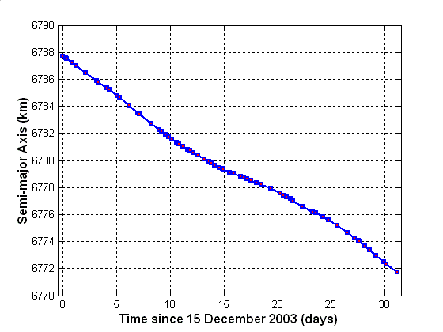

Fig. 1 – Observed semi-major axis decay of BeppoSAX from
15 December 2002 to 15 January 2003

BEPPOSAX REENTRY WINDOW

The expected residual lifetime of the satellite was computed by propagating its last available state vector (epoch: 15 January 2003, 16:02 UTC) with a numerical trajectory predictor including the geopotential harmonics up to the 16th order and degree, the luni-solar attraction, the solar radiation pressure with eclipses and the aerodynamic drag. The air density was computed with the Jacchia-Roberts 1971 model.

Concerning the predicted solar flux at 10.7 cm (used by the atmospheric model as a proxy of the solar irradiance at extreme ultraviolet frequencies) and the geomagnetic planetary index A_{p}, the 27-day (corresponding to one solar rotation) forecasts issued by the NOAA Space Environment Center were adopted. For the subsequent months, such 27-day values were repeated, being considered more realistic and reliable, in the present application, compared to the standard long-term monthly smoothed predictions.

Adopting for BeppoSAX the ballistic parameter estimated by fitting the orbital decay observed during the last month, the nominal reentry date of 22 April 2003 was obtained. In order to take into account the intrinsic uncertainties of this kind of predictions, a reentry window was computed by assuming a variation in the nominal ballistic parameter B_{N} of ± 25%, as shown in Table 1.

Table 1

BeppoSAX Reentry Window

Reentry Window | Criteria | B (m²/kg) | Reentry Date
Opening | B_{N} + 25% | 0.02840 | 4 April 2003
Nominal Reentry | B_{N} | 0.02272 | 22 April 2003
Closure | B_{N} − 25% | 0.01704 | 24 May 2003

The reentry window includes the unavoidable uncertainties on the atmospheric model, the drag coefficient evolution and the space environment predictions (solar flux at 10.7 cm and A_{p}). Based on the experience of the past, the confidence level associated with the reentry window presented in Table 1 is approximately 90%.

NEXT UPDATE

The next reentry prediction will be issued on 30 January 2003.

Prepared by Luciano Anselmo and Carmen Pardini

