ASI Contract No. I/408/02/0 to ISTI/CNR
for the Technical-Scientific Support to the BeppoSAX Satellite
Re-entry Prediction Activities

Risk Analysis and Management of the
BeppoSAX Reentry

Technical Report of Work Package 2
Revision 1.1

Prepared by

Luciano Anselmo

5 March 2003

Istituto di Scienza e Tecnologie dell’Informazione “A. Faedo”
CNR – Area della Ricerca di Pisa
Via G. Moruzzi 1, 56124 Pisa, Italy

TABLE OF CONTENTS

ABSTRACT 2
LATITUDE BELT POTENTIALLY INVOLVED 3
CASUALTY EXPECTANCY 6
RISK ASSESSMENT AND CONTROL 9
REFERENCES 13

ABSTRACT

This report presents the equatorial belt potentially affected by the impact on the ground of the BeppoSAX surviving fragments and a complete list of the countries or territories involved. The casualty expectancy concept is reviewed and applied to the BeppoSAX reentry, emphasizing the nature of the risk on the ground and in the air space.

The potential hazard represented by the surviving fragments is discussed and the predictive data which will be available for civil protection purposes are presented in qualitative and quantitative terms. In particular, a risk time window of 40 minutes will be associated to each final trajectory segment spanning 20 degrees in longitude, in order to provide a simple time table, useful to plan any risk reduction measure deemed appropriate by the responsible territorial authority in the air or on the ground.

LATITUDE BELT POTENTIALLY INVOLVED

A reentry destructive analysis carried out for ASI by HTG [Refs. 1 and 2] has shown that 42 fragments of BeppoSAX, with a total mass of about 656 kg, will reach the ground. The fragments will rain down vertically, with respect to the local horizon, with terminal velocities in between 60 and 465 km/h. The debris footprint on the earth surface, aligned with the sub-satellite track, will be approximately 330 km long. Following the HTG results, the cross-track dispersion might reach ± 0.375 degrees, corresponding to about ± 42 km. This is the sum of the deterministic scattering of the fragments obtained with the SCARAB software (± 0.25 degrees) and the stochastic dispersion computed for the main object (± 0.125 degrees) [Refs. 1 and 2]

The definition of the latitude belt potentially affected by the impact of the surviving fragments results from the following relationship:

L_{max} = I_{max} + δ + Λ, (1)

where L_{max} is the limiting latitude (North or South) of the above mentioned belt, I_{max} is the maximum satellite orbit inclination, δ is a corrective term, for the conversion from geocentric to geodetic coordinates, and Λ is the maximum cross-track dispersion of the fragments. Taking into account the higher orbital inclination foreseen during the reentry window (spring 2003), I_{max} + δ = 3.981 degrees and

L_{max} = 4.356 degrees. (2)

Therefore, the BeppoSAX surviving fragments might reach any location in between 4.356 degrees North and South.

The countries or territories crossed by the above mentioned latitude belt are the following:

- Africa: Burundi, Cameroon, Central African Republic, Congo, Democratic Republic of Congo, Equatorial Guinea, Ethiopia, Gabon, Kenya, Rwanda, São Tomé and Príncipe, Seychelles, Somalia, Sudan, Tanzania, Uganda. Cap Palmas, at the border between Liberia and Côte d’Ivoire, and the Niger river delta, in Nigeria, are also skimmed by the limiting northern latitude;

- Asia: Brunei, Indonesia, Malaysia, Maldives, Singapore;

- Oceania: Baker Island (USA), Federated States of Micronesia, Howland Island (USA), Jarvis Island (USA), Kiribati, Marshall Islands, Nauru, Palau, Papua New Guinea;

- South America: Brazil, Colombia, Ecuador, French Guiana, Guyana, Peru, Suriname, Venezuela.

The equatorial latitude belt potentially affected by the BeppoSAX reentry is presented in Figure 1, plotted on a planisphere showing the population density distribution in 1994. At present (2003), about 270 millions of people reside in the region potentially interested by the impact of the surviving fragments.

In addition to Λ, the amplitude of the risky ground swath (Σ) associated to the predicted reentry trajectory will depend also on a term, ε(λ), resulting from the inaccuracies of the propagated state vector:

$Σ(λ)=Λ+ε(λ)$. (3)

In this equation λ is the latitude of the corresponding sub-satellite point and ε(λ) can be expressed as a function of the error (±η) in the trajectory nodal crossing:

$ε(λ)=η\text{sin}\left(I+δ−\left|λ\right|\right)$. (4)

Again, I is the actual orbit inclination and δ is a corrective term, for the conversion from geocentric to geodetic coordinates.

From Eqs. (3) and (4) it may be found that ε(λ) = 0 when |λ| = I +δ, that is when the sub-satellite geodetic latitude is maximum, while ε(λ) assumes the highest value on the earth equator, where ε(0°) = η sin (I +δ) ≅ 0.069η. Regarding the size of the nodal crossing error, it is given, in kilometers, by:

$η=0\text{.}\text{465}×\left|Δt\right|$, (5)

where Δt is the nodal crossing time difference (in seconds) between the predicted and the actual trajectory, and 0.465 km/sec is the earth’s rotation velocity at the equator. A reasonable estimate of η will be available only during the last few days of satellite lifetime and its final value will critically depend on the last orbital state vector available. However, even a five minutes nodal crossing error translates in ε(0°) = 9.6 km, ε(1°) = 7.3 km, ε(2°) = 4.8 km and ε(3°) = 2.4 km, all values quite small with respect to Λ = 42 km.

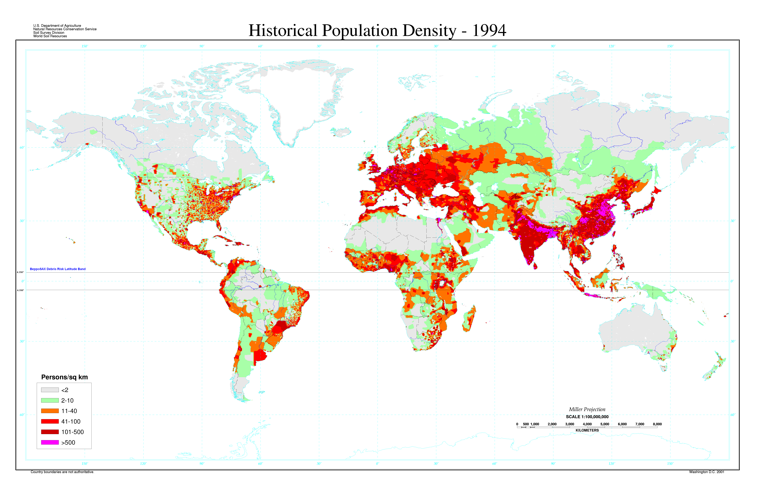
Fig. 1 – Equatorial latitude belt potentially affected by the BeppoSAX reentry

CASUALTY EXPECTANCY

If the BeppoSAX fragments impact in an area of constant population density, the expected average number of casualties E_{c} can be calculated with the following equation:

E_{c} = P_{I} N (A_{c}/A_{R}), (6)

where P_{I} is the probability of impact in the region, N is the total population in the region, A_{c} is the total effective casualty area for the impacting fragments, and A_{R} is the total area of the region. It should be emphasized that E_{c} is not the probability of a casualty: in theory the casualty expectancy may be greater than one, while the probability of casualty can never be.

The formula adopted in the NASA Safety Standard [Refs. 3 and 4] to compute the effective casualty area due to a satellite reentry is:

$A_{c}=\sum_{i=1}^{n}{{\left(\sqrt{A_{h}}+\sqrt{A_{i}}\right)}^{2}}$, (7)

where A_{h} = 0.36 m² is the projected human cross-section and A_{i} is the cross-section of each individual fragment reaching the ground. However, for people in the open, the effective casualty area of impacting inert debris is generally larger, due to winds, trajectory path angle, sliding, skidding or bouncing at ground impact, and splattering or cratering [Ref. 5]. Moreover, explosive debris can significantly increase the casualty area [Ref. 6].

In the case of a reentering satellite like BeppoSAX, the fragments will rain down vertically, with respect to the local horizon, with only a minor horizontal velocity component due to local winds, with negligible consequences. Moreover, any material able to explode or burn should ignite at high altitude, during the breakup phase. Regarding sliding, bouncing or splattering at ground impact, the three effects are generally exclusive and because soft soil tends to be more common than hard surfaces (this is particularly true in the latitude belt potentially interested by the BeppoSAX reentry), the effective casualty area computed using Eq. (7) might be, at most, enhanced by a factor 2 [Ref. 6].

Due to the orbital inclination with respect to the earth equator (≅ 4 degrees), the a priori reentry probability varies as a function of latitude, but for each parallel is independent on the longitude. Of course, the BeppoSAX reentry cannot occur outside the ± 4 degrees latitude belt, while Table 1 summarizes the reentry probability as a function of latitude in the area of the planet potentially affected by the debris fall.

Table 1

BeppoSAX Reentry Probability and Average Casualty Expectancy
as a Function of Latitude

Latitude Belt | Reentry Probability | Casualty Expectancy
3° – 4° S | 0.230 | 1.14 × 10⁻⁴
2° – 3° S | 0.103 | 4.95 × 10⁻⁵
1° – 2° S | 0.086 | 3.96 × 10⁻⁵
0° – 1° S | 0.081 | 3.79 × 10⁻⁵
0° – 1° N | 0.081 | 4.09 × 10⁻⁵
1° – 2° N | 0.086 | 3.01 × 10⁻⁵
2° – 3° N | 0.103 | 3.06 × 10⁻⁵
3° – 4° N | 0.230 | 9.51 × 10⁻⁵
4° S – 4° N | 1.000 | 4.34 × 10⁻⁴
4.356° S – 4.356° N | 1.000 | 4.51 × 10⁻⁴

Following Eq. (6), the expected average number of casualties E_{c} due to the BeppoSAX reentry can be computed as follow:

$E_{c}=\frac{{\text{NA}}_{c}}{4{πR}^{2}\text{sin}L_{\text{max}}}$, (8)

where R is the equatorial radius of the earth and N/(4πR² sin L_{max}) represents the average population density in the latitude belt potentially affected by the satellite debris impact. At present (2003) its value is 6.778 people per square kilometer [Ref. 7]. By adopting the method suggested by NASA [Refs. 3 and 4] and Eq. (7), the debris casualty area (32.42 m²) obtained by the HTG study [Refs. 1 and 2] implies an a priori expected number of human casualties of about 2 × 10⁻⁴. Assuming a further enhancement factor of 2 [Ref. 6], to take into account debris sliding, bouncing or splattering after the ground impact on a typically soft soil, the expected average number of casualties in the latitude belt at risk (± 4.356 degrees) is about 4.5 × 10⁻⁴ (Table 1).

This, of course, is a measure of a collective risk. The individual risk associated with the BeppoSAX reentry is measured by E_{c}/N ≅ 10⁻¹². To put such extremely low individual risk in perspective, the annual individual fatality rate due to a non-occupational accident in a developed country is of the order of 10⁻⁴ [Ref. 8]. It should also be emphasized that the orbital inclination of the BeppoSAX satellite (≅ 4 degrees) guarantees the minimum expected number of casualties for unit casualty area [Ref. 9]. In other words, the same satellite would be potentially more risky in any other inclination, lower or higher, for instance by 15% at zero degrees, by 38% at 15 degrees, and by 85% at 50 degrees [Ref. 9].

For people in the open, the casualty probability P(n) – where n is the number of victims – can be obtained from the average number of expected casualties E_{c} using the following Poisson distribution (see Table 2):

$P(n)=\frac{E_{c^{n}}e^{−E_{c}}}{n!}$. (9)

Currently, about 150-200 tons of orbital objects, mostly concentrated in payloads (satellites), platforms and rocket bodies, reenter the earth atmosphere every year without control. This implies at least 2 or 3 reentry events per months comparable or larger than BeppoSAX, in terms of the expected average number of casualties.

Table 2

Casualty Probability for People in the Open

Number of Victims | Probability
1 | 4.51 × 10⁻⁴
2 | 1.02 × 10⁻⁷
3 | 1.53 × 10⁻¹¹
4 | 1.72 × 10⁻¹⁵
5 | 1.55 × 10⁻¹⁹

RISK ASSESSMENT AND CONTROL

The risk is the product of probability and consequence. For the BeppoSAX reentry, and inside the ± L_{max} latitude belt, the probability of debris fall is 1, but the expected consequences, at least for people in the open, are not particularly adverse with respect to the common risks accepted in the everyday life. For people in buildings or shelters, the casualty area of a satellite surviving fragment may be larger or smaller than its maximum cross-sectional area. The exact outcome depends on the fragment capability of penetrating or gravely damaging the sheltering structure. If this is not the case, the effective casualty area of the fragment for that structure becomes zero.

The risk associated to the reentry can be subdivided in primary and secondary. The primary risk is that due to a direct hit of people in the open by a falling fragment. The secondary risk is instead associated with the consequences of a debris impact on a building, a shelter, a high risk industrial plant (e.g. chemical, nuclear) or a vehicle (e.g. aircraft, ship, or train). The primary risk can be evaluated following the approach described in the previous section, but no easy way to compute the secondary risk is available, also because, in many cases, a very small impact probability is associated with potentially catastrophic consequences. The best strategy, in these situations, would be to take simple and appropriate preventive measures, in order to significantly reduce the adverse consequences of a debris hit.

Concerning the sheltering of people on the ground or the protection of high risk industrial plants, attention should be paid to the fragments capacity to penetrate and seriously damage the structure, to the excess kinetic energy retained by the impactor if penetration occurs, and to the falling structural debris produced by the impact. The same applies, basically, to oceanic ships and to low velocity trains, while high velocity trains could also incur in the secondary consequences of a high velocity impact and/or derailment. For airplanes in flight, moving around at several hundreds of kilometers per hour, the problem is quite different, because even the impact with a debris practically at rest in the air could have severe consequences for the passengers on board; in this case, the fragments mass and composition are more important, to assess the risk, than their kinetic energy.

The analysis carried out by HTG [Refs. 1 and 2] has shown that 42 large fragments of BeppoSAX, with a total mass of about 656 kg, will reach the ground. These fragments will impact the ground, practically aligned to the local vertical, with terminal velocities in between 60 and 465 km/h. The debris footprint on the earth surface, aligned with the sub-satellite track, will be approximately 330 km long and 84 km wide. On the basis of the SCARAB simulations [Refs. 1 and 2], all the above mentioned fragments will impact the ground in between 37 and 41 minutes after the crossing of the reentry interface, at an altitude of 120 km. Smaller centimeter sized fragments (mass ~ 1 g), not modeled in the HTG study, will continue to rain down in the following 20 minutes; the associated risk on the ground will be negligible, but they might represent a potential hazard to the air traffic crossing the reentry air space.

The total kinetic energy of the falling fragments will be 2.35 × 10⁶ J, equivalent to the energy liberated by the explosion of 558 g of TNT. According to the HTG analysis [Refs. 1 and 2], more than 90% of this energy will be concentrated in the top nine energetic objects, while the top ten will account for 91.8% of the total kinetic energy and 83.7% of the surviving mass (Table 3). All of them will impact the ground in between 38 and 39 minutes after the crossing of the reentry interface.

Table 3

BeppoSAX Fragments Rated by Kinetic Energy

HTG No. | Mass  [kg] | Kinetic Energy  [J] | Equivalent Energy of TNT [g] | Time of Impact After Reentry [min]
34 | 93 (14.2%) | 631,540.7 (26.9%) | 150 | 38.2
3 | 72 (11.0%) | 420,544.1 (17.9%) | 100 | 38.4
35 | 72 (11.0%) | 366,806.3 (15.6%) | 87 | 38.5
41 | 120 (18.3%) | 279,733.4 (11.9%) | 66 | 38.7
28 | 60 (9.1%) | 106,555.6 (4.5%) | 25 | 38.1
27 | 60 (9.1%) | 104,306.2 (4.4%) | 25 | 38.1
20 | 11 (1.7%) | 93,735.7 (4.0%) | 22 | 38.3
8 | 30 (4.6%) | 82,733.2 (3.5%) | 20 | 38.7
2 | 15 (2.3%) | 37,733.0 (1.6%) | 9 | 38.3
40 | 16 (2.4%) | 34,129.2 (1.5%) | 8 | 39.0

Based on the previous reentry campaigns experience, during the last three days the reentry predictions of an uncontrolled satellite in circular orbit like BeppoSAX are affected by an uncertainty of approximately ± 15% of the residual lifetime. Therefore, during the very last days and hours, the amplitude of the reentry uncertainty window will critically depend on the availability of timely and updated orbital determinations, which in this case can only be provided by the US Space Command (USSPACECOM) through NASA.

The evolution of the reentry uncertainty window, as a function of the satellite residual lifetime and state vector availability, is shown in Table 4. It is evident that the amplitude of the final reentry window that might be issued before the event critically depends on the last state vector available for the analysis and propagation. The timely availability of a two-line orbital elements set referring to 6 hours before reentry would reduce the final uncertainty on the predicted reentry time and impact on the ground of the main fragments to about ± 50 minutes, corresponding approximately to one full orbital track.

The amplitude of the final reentry uncertainty window will have a substantial effect on the amount and quality of data that might be provided for the control and reduction of the risk. In any case, the final window will include a few orbital tracks (hopefully just one), with an associated ground swath of ± [Λ + ε(λ)] km. The tracks will be subdivided in segments, spanning 20 degrees in longitude, and for each segment a risk time window of 40 minutes will be specified, valid for both ground and air space. In total, 18 trajectory segments, with the associated risk time windows, will be specified for each orbital track left in the reentry uncertainty window. As an example, if Figure 2 represents a portion of the final sub-satellite track of BeppoSAX, a risk time window will be provided for the trajectory segment in between 60 and 80 degrees West, another for the trajectory segment in between 40 and 60 degrees West, and so on.

Table 4

Time Evolution of the Reentry Uncertainty Window Amplitude

State Vector Epoch  [hours to reentry] | State Vector Availability,  Processing & Propagation  [hours to reentry] | Reentry Time Uncertainty  [time/revolutions]
– 72 | – 69 | ± 10.8 hrs / 14.4 rev
– 48 | – 45 | ± 7.2 hrs / 9.6 rev
– 36 | – 33 | ± 5.4 hrs / 7.2 rev
– 24 | – 21 | ± 3.6 hrs / 4.8 rev
– 18 | – 15 | ± 2.7 hrs / 3.6 rev
– 12 | – 9 | ± 1.8 hrs / 2.4 rev
– 8 | – 5 | ± 1.2 hrs / 1.6 rev
– 6 | – 3 | ± 54 min / 1.2 rev
– 4 | – 1 | ± 36 min / 0.8 rev
– 3 | 0 | ± 27 min / 0.6 rev
– 2 | + 1 | ± 18 min / 0.4 rev
– 1 | + 2 | ± 9 min / 0.2 rev

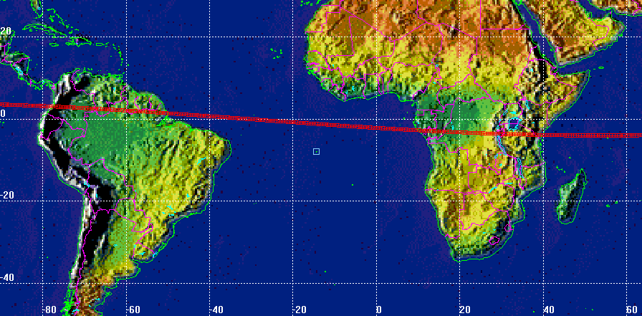

Fig. 2 – Example of final sub-satellite track
The risk time window amplitude (40 minutes) will take into account the uncertainty on the time at which the main objects will hit the ground (± 10 minutes) and the time needed for the small centimeter sized particulate produced by the event to rain down through the affected air space (+ 20 minutes). In other words, the risk time window associated to a specific location along the final sub-satellite track will be defined as follow:

Risk Time Window = Predicted Main Object Impact Time (UTC) $\left\{\frac{+\text{30}\text{min}}{−\text{10}\text{min}}\right.$. (10)

In theory, any location along the final sub-satellite track should have its own risk time window. However, by assuming the corresponding central value for each adjacent trajectory segment spanning 20 degrees in longitude, a maximum bias of ± 2.5 minutes is introduced; this small value can be clearly considered absorbed in the larger impact time uncertainties given above (± 10 minutes) and in the overall risk time window of 40 minutes.

REFERENCES

- Lips T., BeppoSAX Re-entry Analysis with SCARAB, HTG-Report-02-8, Revision 1.0, 30 September 2002.
- Lips T., Destruction Re-entry Analysis of BeppoSAX with SCARAB, Final Presentation, Rome, 5 September 2002.
- NASA Safety Standard: Guidelines and Assessment Procedures for Limiting Orbital Debris, NSS 1740.14, August 1995.
- Bouslog, S., K. Wang, B. Ross and C. Madden, Reentry Survivability and Risk Analysis, NASA/JSC Technical Report JSC-27232, September 1995.
- Montgomery R.M. and J.A. Ward Jr., Casualty Areas from Impacting Inert Debris for People in the Open, RTI Report No. RTI/5180/60-31F, 13 April 1995.
- Smith P.G., Expected Casualty Calculations for Commercial Space Launch and Reentry Missions, Advisory Circular No. 431.35-1, Draft, Federal Aviation Administration, 12 April 1999.
- Johnson, N.L., Personal Communication, 24 January 2003.
- Anselmo L., B. Bertotti and P. Farinella, Detriti Spaziali: Un fattore di rischio che incombe sul futuro delle attività in orbita, CUEN, Napoli, 1999.
- Kato A., Study for IADC Re-entry Safety Assessment Procedure, NASDA-CRE01004, 9 March 2001.

DOCUMENT STATUS SHEET

DOCUMENT TITLE:
Risk Analysis and Management of the BeppoSAX Reentry

DOCUMENT DESCRIPTION:
Technical Report of Work Package 2 - ASI Contract No. I/408/02/0 to ISTI/CNR for the Technical-Scientific Support to the BeppoSAX Satellite Re-entry Prediction Activities

ISSUE | REVISION | DATE | REASON FOR CHANGE
Draft | 0.1 | 21 February 2003 | Preliminary version
Draft | 0.2 | 26 February 2003 | Version to be internally reviewed
Final | 1.0 | 27 February 2003 | Final version after internal review
Final | 1.1 | 5 March 2003 | Addition of casualty expectancy as a function of latitude and casualty probability upon ASI request at Progress Meeting 1

SIGNATURES AND APPROVALS
 | DATE | NAME | SIGNATURE
Prepared | 5 March 2003 | Luciano Anselmo
Checked | 5 March 2003 | Carmen Pardini
Approved | 5 March 2003 | Luciano Anselmo
Authorized | 5 March 2003 | Carmen Pardini

